Novel Interaction Technologies

|  | Julia Gabajova  Middlesex University, London  Email: [JG1004@live.mdx.ac.uk](mailto:JG1004@live.mdx.ac.uk) |  |
| --- | --- | --- |

# Introduction

This paper introduces multiple Interaction Technologies including Tangible User Interfaces, Ubiquitous Computing, Augmented Reality, Haptic Interaction, Wearable Technology and Proxemic Interaction. The summary of each of this technology will be provided together with their advantages and disadvantages. Furthermore, the significant difference between these technologies and key characteristics will be discussed as well.

# Tangible user interfaces (TUI)

TUI is a user interface, will allow users to interact with digital information through the physical environment. The digital objects are represented as an intangible output. The TUI is commonly comprised with display of digital elements such as monitor, projector or a physical device. The advantages of TUI are direct manipulation with physical objects, accessibility and impact on usability, which improve learning performance, encourage exploration and empower collaboration. However, the TUI is challenging to program and it is not suitable for small graphic displays.

The MIT Tangible Media Group is headed by professor Hiroshi Ishii. His vision for tangible user interfaces is called Tangible Bits. The Tangible Bits are used to give physical form to digital information. This group continuously experimenting and developing with TUIs applications. One of the technology invented by this group is called inFORM. This technology, allows physical manipulation of virtual images. A user in one location can put an object in front of the sensing camera, which sends signals to a motorized pin screen. The pin screen is located somewhere else, where the virtual image will pop out. Fiure1 shows how the interaction works. The user is moving hands in one location and the hands manipulating with the red ball on the pin screen located somewhere else. [1]

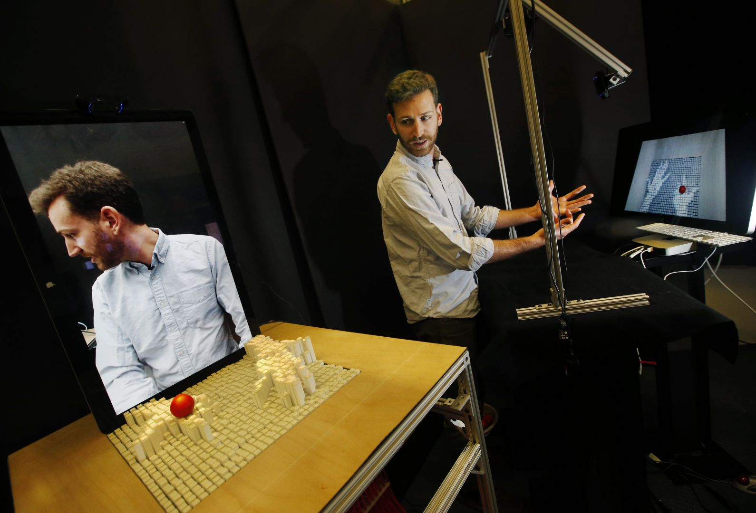

Figure 1

Key characteristics:

* Tangible representations are computationally coupled to digital information
* Tangible representations embody mechanism for interactive control
* Tangible representations are perceptually coupled to tangible and intangible digital representation
* Tangible state embodies key aspects of the digital state of the system

# ubiquitous computing

Ubiquitous computing is also known as pervasive computing. This computing is made to occur anytime and anywhere. The key feature of this computing is the creation of smart products connected together. For instance, automated home control, which uses the data gleaned sensors, that enables to control the lighting and temperature in your home. The system will maximally comfortable environment, reduce waste and gain sustainability of an environment. However, it is not easy to manage adequate protection of privacy, as the pervasive system collects sensitive personal data, which lead to technical, legal and ethical challenges. [2]

Key characteristics:

* Interoperability,
* Services,
* Adaptability
* Context awareness.

# Augmented reality(AR)

AR has the ability to overlay digital information or objects over the real world view using either special equipment (headset), a camera or a smartphone. [3]

One of the advantages of AR system is that the user can see a significant difference between real life and the virtual world. AR have wide range of application in different areas such as Education, Entertainment, Assembly and maintenance.

One of the example is AR sandbox created for education, where students can learn about topography. The sand is augmented with simulated water, elevation color map and topographic contour lines displayed in real-time. The user can manipulate with the sand and see how the water flows around the landscape as shown on Figure2. [4]

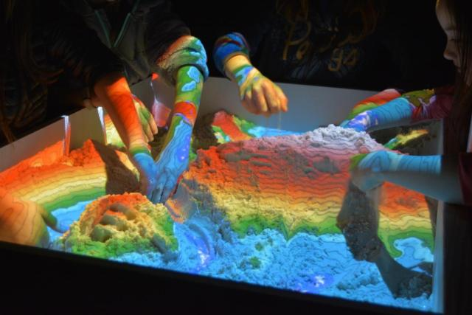

Figure

However, AR have some disadvantages as well. For instance, addictive gaming features can create a health issues. It can also lead to injuries or accidents, as the usage of AR is unsupervised. The increase of ethical dilemma, and disassociation of reality, where user spend so much time in the virtual world, that they cannot distinguish between the real and virtual world. AR also prone to cyber-crimes. [5]

Key characteristics:

* Combines real and virtual objects in a real environment
* Interactive in real-time
* Registered and alignment in 3D

# haptic interaction

Haptic or “haptic feedback” using the sense of touch to produce information to a user. Related to sensory touch, there are three sensory systems in humans: Kinesthetic Proprioceptive (joint speed, muscle tension and length) and Cutaneous (temperature, skin vibration, skin stretch, pain). The haptic uses tactile sensors that measure force, and the user receive sensation feedback in hand or other parts of the body. Haptics technology is usually used for games, but also is used for education and trainings, where the tasks require hand to eye coordination, for instance for spaceship maneuvers or surgery. [6]

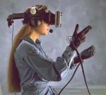The advantage of haptic technology is that it creates special type of communication – touch, where user can take the advantage of sense of this direct feeling, it is easy to access and use, however, the technology is not very commonly used, therefore, it is very expensive. Another disadvantage is that during the interaction the degradation is moving, and the parts tend to fail when wearing this device. Due to this moving mechanism issue, Samsung had to recall their version of folding phones, which was causing failure of screens. In the Figure3, can be seen one of the equipment that haptic technology uses – the wired gloves and head-mounted display.

Figure 4

Interaction will give the user sensational feedback. For instance, if the user is playing a game and if the player gets shot, it will feedback the player in the form of vibrations, so the user can feel the bullet hit on their body by applying the force on that specific area. [7]

# Wearable technology

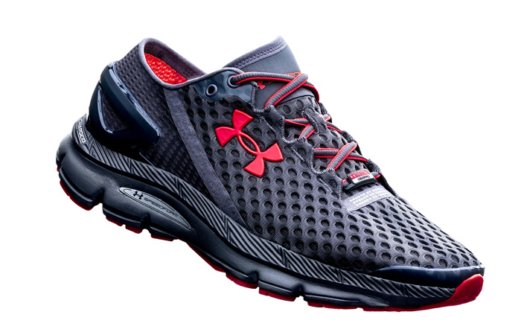This technology is category of smart electronic devices which can be incorporated in clothing, worn as accessories or even implanted into the skin. These devices are powered by microprocessors with the ability to send and receive data. For instance, this smart running shoes, which using a chip with build in sensors, can keep track of your performance such as distance, duration, calories burned, cadence etc. Once you finish running, you be able to synchronize with your smart phone via Bluetooth, to review the status using the UI application. [8]

Figure 5

The advantage of this technology is Data accuracy, efficiency, always staying connected if using wearable watch, it can alert the user with messages, incoming calls, emails etc. The disadvantage of this technology is price, wearable batteries do not last long and small charging mechanisms which can be very tricky for elderly people. [9]

# Proxemic interaction

Dynamic Peripheral Floor Visualizations for mediating revealing large surface interactions. This displays often react to the presents of a user. For example, using Halo that provide feedback around the user feats, which indicate when the user has been tracked and in what position they are in, therefore, the system gives continuous feedback where the user is being recognized. The green tracking represents accurate tracking, yellow represents inaccurate tracking and red tracking shows when tracking is lost as 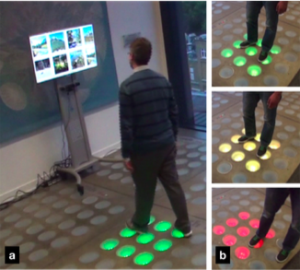shown on the Figure6. Tracking problems can occur if the user is standing out of the tracking area. Halo is designed for multiple users. Each user had their own tracking Halo.

Figure 6

The advantage of this technology is quality of tracking and immediate feedback. For instance, proxemics interactive game experience could be helpful to use this tracking accuracy information for players.However, using this technology has some disadvantages, where the amount of the information is limited and may use low-resolution for floor display. [10]

Key characteristics:

* Sensing devices
* Sensing people
* Sensing presence at specific locations
* Sensing continuous distance and orientation

# Disscussion

Both Tangible User Interface and Augmented Reality display a digital information in the manipulate physical environment. They can be employed to improve learning experience and support collaboration. However, AR does not necessarily use tangible elements, which allows the technology to be more easily deployed compared to the TUI.

Wearable technology, such as fitness tracker and smart watches, can be seen in the form of Ubiquitous computing. It moves the web interaction away from the current way of communication with others, retrieving information from the internet, receiving or sending messages through devices, such as smartphones, desktops, tablets to the embedded process in our home, cars etc. However, all these devices need to be connected to broadcast via Wi-Fi or used near field communication. The disadvantage of the technology for instance, the fitness tracker the recorded data are not controlled by measured party, but usually these data are sent to the storage services of the device owners.

# Conclusion

All these technologies have their advantages and disadvantages. There exist many situations in which one can be more suitable than another, but, there is no scenario which would one technology be best for all these scenarios. The combination of these technologies could be the best approach.

# References

1. Phys.org. (2014). *New MIT technology allows 3D image interaction*. [online] Available at: https://phys.org/news/2014-01-mit-technology-3d-image-interaction.html [Accessed 8 Apr. 2019].
2. Reference. (2019). *What Are the Advantages and Disadvantages of Ubiquitous Computing?*. [online] Available at: https://www.reference.com/history/advantages-disadvantages-ubiquitous-computing-8297c7a9ffaa845 [Accessed 8 Apr. 2019].
3. Mayoral, J. (2017). *Augmented Reality - 5 facts you should know | Augmented Reality SDK*. [online] Augmented Reality SDK. Available at: https://www.viewar.com/5facts-on-augmented-reality/ [Accessed 8 Apr. 2019].
4. Arsandbox.ucdavis.edu. (2019). *Augmented Reality Sandbox*. [online] Available at: https://arsandbox.ucdavis.edu/ [Accessed 21 Apr. 2019].
5. Dhruv, S. (2018). *Pros and Cons of Augmented Reality Apps Development in 21st Century - Aalpha*. [online] Aalpha. Available at: https://www.aalpha.net/blog/pros-cons-augmented-reality-apps-development/ [Accessed 21 Apr. 2019].
6. Chan, J., Gong, S. and Kuan, J. (2011). *The World of Haptics*. [online] The World of Haptics. Available at: https://group2haptics.wordpress.com/ [Accessed 9 Apr. 2019].
7. Bhosale, V. (2018). *What is the difference between haptic technology and virtual reality?*. [online] Quora. Available at: https://www.quora.com/What-is-the-difference-between-haptic-technology-and-virtual-reality [Accessed 22 Apr. 2019].
8. UrbanWearables.Technology. (2018). *The Best Smart Running Shoes - Wearable Technology*. [online] Available at: https://urbanwearables.technology/best-smart-running-shoes-wearable-technology/ [Accessed 9 Apr. 2019].
9. Humavox. (2016). *Wearable Tech Advantages & Disadvantages - Humavox*. [online] Available at: http://www.humavox.com/blog/exploring-advantages-disadvantages-wearable-tech/ [Accessed 21 Apr. 2019].
10. Vermeulen, J., Luyten, K., Coninx, K., Marquardt, N. and Bird, J. (2015). [online] Jovermeulen.com. Available at: http://jovermeulen.com/uploads/Research/VermeulenLuytenConinxMarquardtBird_interact2015.pdf [Accessed 21 Apr. 2019].